Himmelbjergmesterskab 2016 - standard & latin https://www.facebook.com/images/emoji.php/v5/fd2/1/16/1f604.png😄

[[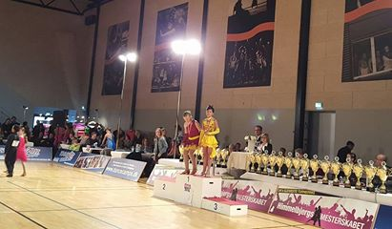](https://www.facebook.com/photo.php?fbid=10154611577197856&set=pcb.10154611577582856&type=3)](https://www.facebook.com/photo.php?fbid=10154611577197856&set=pcb.10154611577582856&type=3)

[[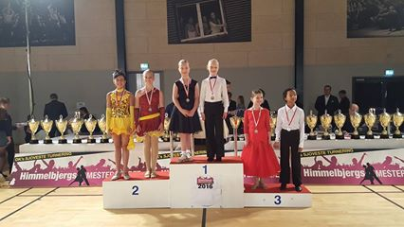](https://www.facebook.com/photo.php?fbid=10154611577247856&set=pcb.10154611577582856&type=3)](https://www.facebook.com/photo.php?fbid=10154611577247856&set=pcb.10154611577582856&type=3)

[[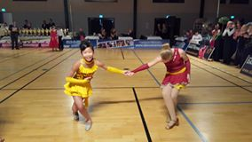](https://www.facebook.com/photo.php?fbid=10154611577302856&set=pcb.10154611577582856&type=3)](https://www.facebook.com/photo.php?fbid=10154611577302856&set=pcb.10154611577582856&type=3)

[[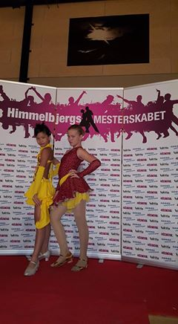](https://www.facebook.com/photo.php?fbid=10154611577387856&set=pcb.10154611577582856&type=3)](https://www.facebook.com/photo.php?fbid=10154611577387856&set=pcb.10154611577582856&type=3)

[[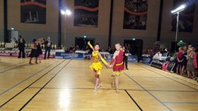](https://www.facebook.com/photo.php?fbid=10154611577472856&set=pcb.10154611577582856&type=3)](https://www.facebook.com/photo.php?fbid=10154611577472856&set=pcb.10154611577582856&type=3)

Øverst på formularen

Nederst på formularen